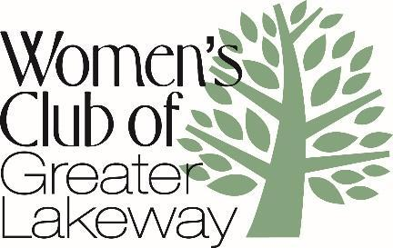
Luncheon Reservation –November 15, 2021
(Social Time- 9:30/Meeting-10:00)
Flintrock Falls Country Club
Navigate to security gate: 100 Jack Nicklaus Drive
Menu
Nutty Chicken Salad Croissant
Vine Ripened Tomato, Seasonal Greens,
Local Honey Aioli
Potato Chips
Chef’s Choice of Dessert
__________________________________

Enclosed is a check payable to WCGL in the amount of
$23/Member or $28/non-member/guest.
Reservations must be received by Friday, November 5th
Mail your check to Janice Zehrer
105 Golf Crest Cove, Lakeway 78734,
or leave it under front door mat.
janicezehrer@gmail.com
Due to mail delivery issues,
please add your return address to the front of the envelope.

Member Name______________________________________
If you are a new member since May 2021, please check here__
Guest Name_______________________ (if attendance allows)

There will be no refunds after the November 5th deadline, and funds are not transferable.

